KIDS TODDLER

**Food and Nutrition:**

**WOODWARDS:**

Depending on the age and the amount of physical activity your toddler is engaged in, he needs 1000-1400 calories each day. Get the best food and nutrition recommendations here along with comprehensive food charts, healthy recipes on how to add more nutrients in your child's diet plus all that you need to know about your toddler's dietary and nutritional needs and restriction.

Is Wood wards Gripe Water Good For Babies?

gripe water was considered a herbal remedy, the Food and Drug Administration (FDA) has not approved it, but the vast majority of parents like this. It has no effect on babies suffering from colic, as it does not lessen stomach discomfort .

What Is Wood wards Gripe Water Used For?

For the symptomatic relief of distress associated with wind by infants as young as 1 year of age. It is possible to give this dosage at any point during or after each feed.

What Are The Benefits Of Wood wards?

Helps during Constipation.

The goal is to provide relief in conjunction with the teething process.

Cures Gastrointestinal issues.

Prevents Indigestion.

Lactose intolerant people are cured by this treatment.

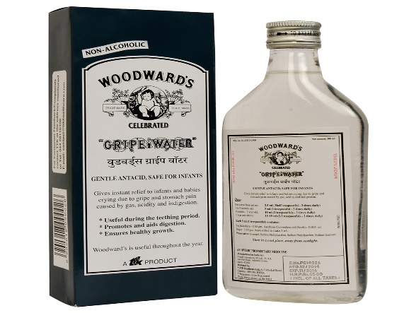

VASA KOMMU:

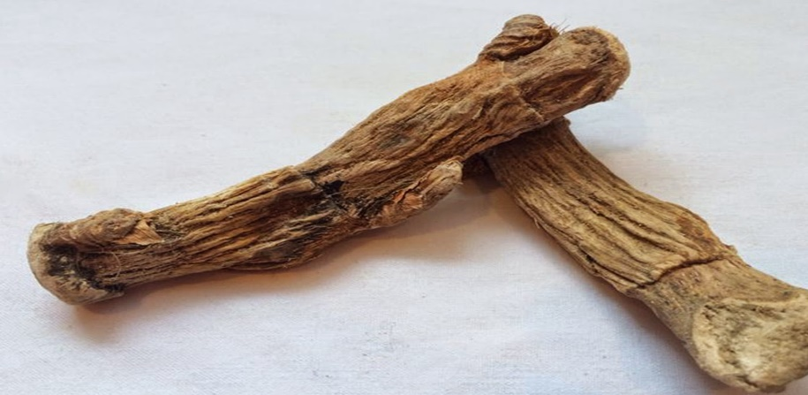

Uses: Vasa improves voice quality and relives cough. It aids in pacifying blood disorders like nasal bleeding, blood vomiting or heavy menstrual bleeding. It is used to treat fever and skin diseases. Vasa can help relieve excess thirst.

SIDE EFFECTS :

Hazards and/or side effects not known for proper therapeutic dosages. Larger doses can cause irritation and vomiting. It is not recommended during pregnancy except in assisting delivery. Ardusa/Vasaka has anti-plantation and abortifacient activities, therefore it must not be used during pregnancy.

Diet for a 6-month-old – Week 1, Day 1

Early morning Mother’s milk /formula feed

Breakfast -Stewed apple

Mid-morning -Mother’s milk /formula feed

Lunch -Mother’s milk /formula feed

Evening -Mother’s milk /formula feed

Dinner -Mother’s milk /formula feed

Diet for a 6-month-old – Week 1, Day 2

Early morning -Mother’s milk /formula feed

Breakfast - Stewed apple

Mid-morning -Mother’s milk /formula feed

Lunch -Mother’s milk /formula feed

Evening -Mother’s milk /formula feed

Dinner -Mother’s milk /formula feed

**Diet for a 6-month-old – Week 1, Day 3**

Early morning - Mother’s milk /formula feed

Breakfast - Stewed apple

Mid-morning -Mother’s milk /formula feed

Lunch -Mother’s milk /formula feed

Evening -Mother’s milk /formula feed

Dinner -Mother’s milk /formula feed

**Diet for a 6-month-old – Week 1, Day 4**

Early morning -Mother’s milk /formula feed

Breakfast -Stewed apple

Mid-morning -Mother’s milk /formula feed

Lunch -Moong dal (yellow split gram) soup

Evening -Mother’s milk /formula feed

Dinner -Mother’s milk /formula feed

**Diet for a 6-month-old – Week 1, Day 5**

Early morning -Mother’s milk /formula feed

Breakfast -Stewed apple

Mid-morning - Mother’s milk /formula feed

Lunch -Moong dal (yellow split gram) soup

Evening -Mother’s milk /formula feed

Dinner -Mother’s milk /formula feed

**Diet for a 6-month-old – Week 1, Day 6**

Early morning -Mother’s milk /formula feed

Breakfast -Stewed apple

Mid-morning -Mother’s milk /formula feed

Lunch -Moong dal (yellow split gram) soup

Evening -Mother’s milk /formula feed

Dinner -Mother’s milk /formula feed

**Diet for a 6-month-old – Week 1, Day 7**

Early morning - Mother’s milk /formula feed

Breakfast -Stewed pear

Mid-morning -Mother’s milk /formula feed

Lunch - Dal (lentil) -spinach soup

Evening -Mother’s milk /formula feed

Dinner -Mother’s milk /formula feed

**Diet for a 6-Month-Old – Week 2, Day 1**

Early morning - Mother’s milk /formula feed

Breakfast -Stewed pear

Mid-morning -Mother’s milk /formula feed

Lunch -Dal (lentil) -spinach soup

Evening -Mother’s milk /formula feed

Dinner -Mother’s milk /formula feed

**Diet for a 6-Month-Old – Week 2, Day 2**

Early morning -Mother’s milk /formula feed

Breakfast -Spinach-pumpkin puree

Mid-morning -Mother’s milk /formula feed

Lunch -Stewed apple

Evening -Mother’s milk /formula feed

Dinner -Mother’s milk /formula feed

**Diet for a 6-Month-Old – Week 2, Day 3**

Early morning Mother’s milk /formula feed

Breakfast Spinach-pumpkin puree

Mid-morning Mother’s milk /formula feed

Lunch Stewed pear

Evening Mother’s milk /formula feed

Dinner Mother’s milk /formula feed

Diet for a 6-Month-Old – Week 2, Day 4

Early morning Mother’s milk /formula feed

Breakfast Spinach-pumpkin puree

Mid-morning Mother’s milk /formula feed

Lunch Rice porridge

Evening Mother’s milk /formula feed

Dinner Mother’s milk /formula feed

Diet for a 6-Month-Old – Week 2, Day 5

Early morning Mother’s milk /formula feed

Breakfast Stewed apple

Mid-morning Mother’s milk /formula feed

Lunch Rice porridge

Evening Mother’s milk /formula feed

Dinner Mother’s milk /formula feed

Diet for a 6-Month-Old – Week 2, Day 6

Early morning Mother’s milk /formula feed

Breakfast Mashed potato

Mid-morning Mother’s milk /formula feed

Lunch Rice porridge

Evening Mother’s milk /formula feed

Dinner Mother’s milk /formula feed

Diet for a 6-Month-Old – Week 2, Day 7

Early morning Mother’s milk /formula feed

Breakfast Mashed potato

Mid-morning Mother’s milk /formula feed

Lunch Dal (lentil) -spinach soup

Evening Mother’s milk /formula feed

Dinner Mother’s milk /formula feed

Diet for a 6-Month-Old – Week 3, Day 1

Early morning Mother’s milk /formula feed

Breakfast Stewed pear

Mid-morning Mother’s milk /formula feed

Lunch Rice porridge with mashed carrot

Evening Mother’s milk /formula feed

Dinner Mother’s milk /formula feed

Diet for a 6-Month-Old – Week 3, Day 2

Early morning Mother’s milk /formula feed

Breakfast Spinach-pumpkin puree

Mid-morning Mother’s milk /formula feed

Lunch Rice porridge with mashed carrot

Evening Mother’s milk /formula feed

Dinner Mother’s milk /formula feed

Diet for a 6-Month-Old – Week 3, Day 3

Early morning Mother’s milk /formula feed

Breakfast Stewed apple

Mid-morning Mother’s milk /formula feed

Lunch Rice porridge with mashed carrot

Evening Mother’s milk /formula feed

Dinner Mother’s milk /formula feed

Diet for a 6-Month-Old – Week 3, Day 4

Early morning Mother’s milk /formula feed

Breakfast Carrot-beetroot puree

Mid-morning Mother’s milk /formula feed

Lunch Spinach-pumpkin puree

Evening Mother’s milk /formula feed

Dinner Mother’s milk /formula feed

Diet for a 6-Month-Old – Week 3, Day 5

Early morning Mother’s milk /formula feed

Breakfast Carrot-beetroot puree

Mid-morning Mother’s milk /formula feed

Lunch Dal (lentil) -spinach soup

Evening Mother’s milk /formula feed

Dinner Mother’s milk /formula feed

Diet for a 6-Month-Old – Week 3, Day 6

Early morning Mother’s milk /formula feed

Breakfast Carrot-beetroot puree

Mid-morning Mother’s milk /formula feed

Lunch Stewed pear

Evening Mother’s milk /formula feed

Dinner Mother’s milk /formula feed

Diet for a 6-Month-Old – Week 3, Day 7

Early morning Mother’s milk /formula feed

Breakfast Rice porridge with mashed carrot

Mid-morning Mother’s milk /formula feed

Lunch

Lauki (bottle gourd)- moong dal (green gram split) soup

Evening Mother’s milk /formula feed

Dinner Mother’s milk /formula feed

Diet for a 6-Month-Old – Week 4, Day 1

Early morning Mother’s milk /formula feed

Breakfast Mashed potato

Mid-morning Mother’s milk /formula feed

Lunch

Lauki (bottle gourd) moong dal ( green gram split) soup

Evening Mother’s milk /formula feed

Dinner Mother’s milk /formula feed

Diet for a 6-Month-Old – Week 4, Day 2

Early morning Mother’s milk /formula feed

Breakfast

Sweet potato + poha (flattened rice) powder

Mid-morning Mother’s milk /formula feed

Lunch Tomato- pumpkin soup

Evening Mother’s milk /formula feed

Dinner Mother’s milk /formula feed

Diet for a 6-Month-Old – Week 4, Day 3

Early morning Mother’s milk /formula feed

Breakfast

Sweet potato + poha (flattened rice) powder

Mid-morning Mother’s milk /formula feed

Lunch Lauki (bottle gourd) rice

Evening Mother’s milk /formula feed

Dinner Mother’s milk /formula feed

Diet for a 6-Month-Old – Week 4, Day 4

Early morning Mother’s milk /formula feed

Breakfast

Sweet potato + poha (flattened rice) powder

Mid-morning Mother’s milk /formula feed

Lunch

Rice porridge with mashed carrot

Evening Mother’s milk /formula feed

Dinner Mother’s milk /formula feed

Diet for a 6-Month-Old – Week 4, Day 5

Early morning Mother’s milk /formula feed

Breakfast Dal (lentil) -spinach soup

Mid-morning Mother’s milk /formula feed

Lunch Palak (spinach)khichdi

Evening Mother’s milk /formula feed

Diet for a 6-Month-Old – Week 4, Day 6

Early morning Mother’s milk /formula feed

Breakfast Mashed potato

Mid-morning Mother’s milk /formula feed

Lunch

Ragi (finger millet) – moong dal (green gram split) soup

Evening Mother’s milk /formula feed

Dinner Mother’s milk /formula feed

Diet for a 6-Month-Old – Week 4, Day 7

Early morning Mother’s milk /formula feed

Breakfast Spinach-pumpkin puree

Mid-morning Mother’s milk /formula feed

Lunch

Ragi (finger millet) – moong dal (green gram split) soup

Evening Mother’s milk /formula feed

Dinner Mother’s milk /formula feed