**FOR MIDDLE AGE PEOPLE**

**Lean Beef:**

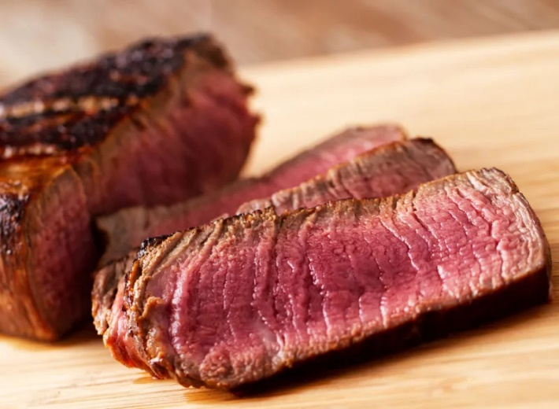

medium rare steak full fat health foods

Shutterstock

"For women, iron is specifically important, as your body naturally loses iron during pregnancy and menstruation. Iron deficiency can lead to anemia, which can cause extreme lethargy, weakness, dizziness, headaches, and more," Stricoff says.

Heme-iron, which is found in meat, is absorbed better than non-heme iron, which is found in plants such as spinach.

"However, if you consume iron from plants with vitamin C, it will increase the absorption. For example, use a citrus-based dressing on a leafy green salad to maximize your iron absorption," she says.

Beef is also a boon in terms of its protein quotient. For example, a three-ounce sirloin steak will score you 23 grams.

"I advise my clients to even out protein intake between 25 to 30 grams at each meal. This is more important after your 30s because, with each subsequent decade, there is a 3 to 8 percent loss of muscle, so it's important to keep what you have by fueling your muscles with protein," says Jonathan Valdez, RD, a registered dietitian at Genki Nutrition in Astoria, New York, and a media spokesperson for New York State Academy of Nutrition and Dietetics.

**Broccoli:**

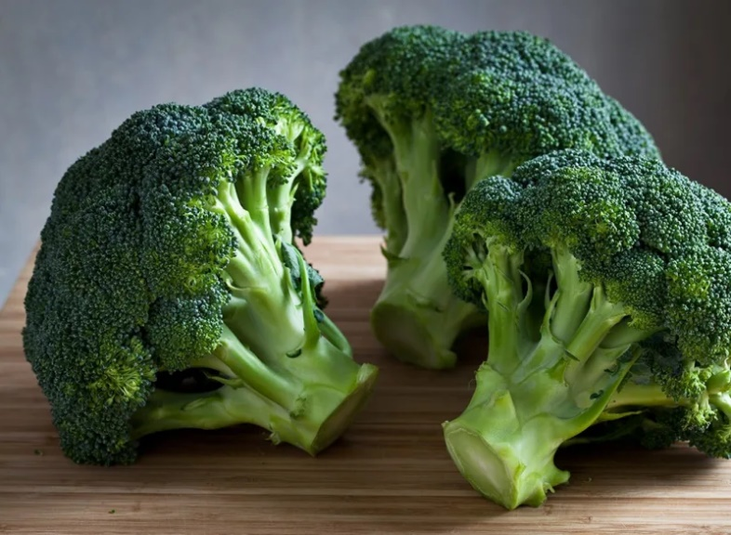

Shutterstock

Don't detox. Do go big on broccoli.

"Cruciferous vegetables are the 'detox' members of the plant kingdom. Rather than leaning on dangerous laxative teas, the Master Cleanse, and juice fasts (which drop pounds fast, but not permanently) eat foods like broccoli, cauliflower, and Brussels sprouts," Dixon says. "Cruciferous vegetables support the body's natural detoxification processes. We have enzymes, or chemical systems, within our cells (particularly in the liver), and the activity of these enzymes is bolstered by the presence of specific substances found only in cruciferous vegetables."

Women should grab an extra bunch of broccoli, since it's been shown to aid the body with estrogen metabolism, helping to keep estrogen levels in a healthier (lower) range. Excess estrogen is implicated in hormone-related cancers: breast, ovarian, and uterine, Dixon says.

**Citrus Fruits:**

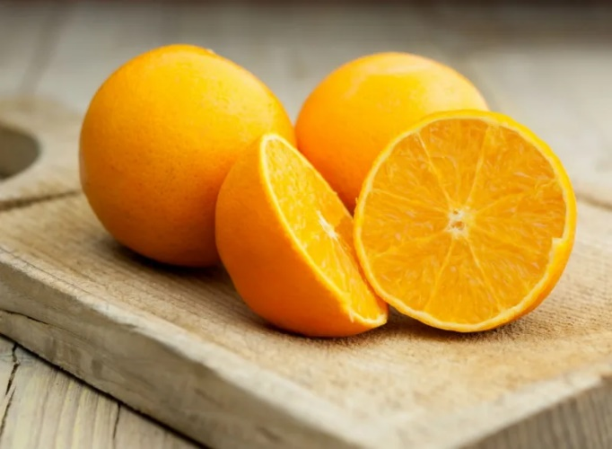

Sliced orange

Shutterstock

"As we get older, collagen—which is the building block of our skin—becomes more and more degraded. This is one reason why our skin looks thinner and more wrinkled with age," Youn says. "Vitamin C fights free radicals which damage our skin and our inner organs and is a critical part of the formation of collagen."

Oranges, lemons, kiwi, strawberries, tomatoes, and kale are all C standouts.

**Bone Broth:**

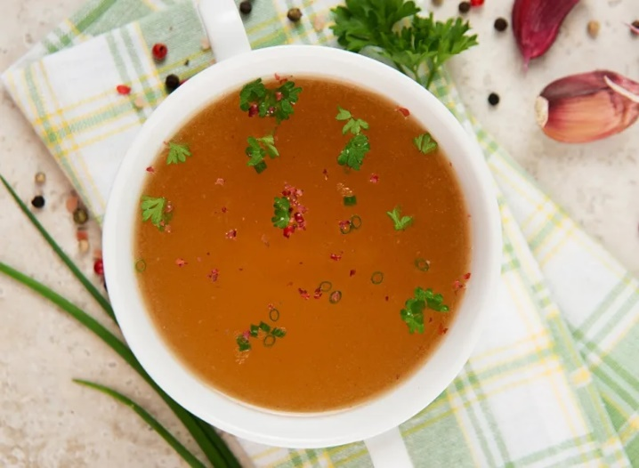

Bone broth in bowl

Shutterstock

Collagen can also be replenished by bone broth.

"Collagen-rich foods and drinks make the skin look and feel younger and healthier, but that's just the beginning. They can also help soothe the gut and improve the microbiome," Youn says.

For the biggest benefit, dress up your broth with colorful vegetables.

"This resulting soup is a great source of collagen protein, which supports smoother skin, stronger and more resilient bones and joints, and even helps with blood-sugar control and detoxification," Schoenfeld says. "By cooking the vegetables in the broth, the soup also provides potassium to support energy production. When we don't have enough potassium, our body 'steals' it from our muscles, accelerating the muscle loss that begins to take place after our 20s.".

**Vegetable Soup:**

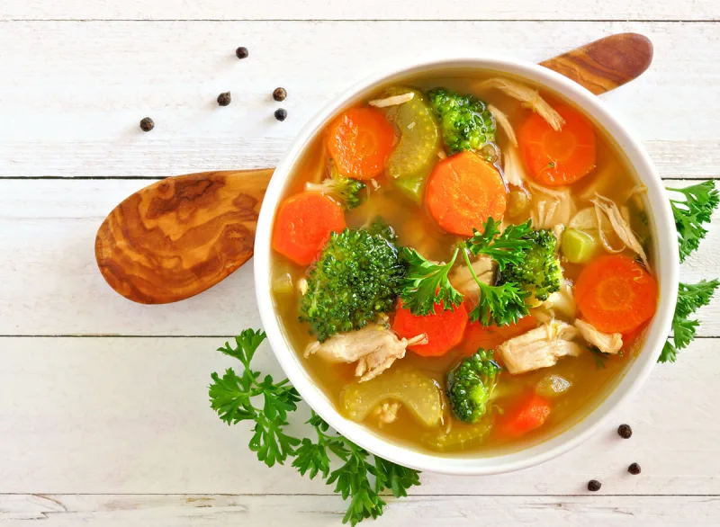

Shutterstock

For the biggest benefit, dress up your broth with colorful vegetables.

"This resulting soup is a great source of collagen protein, which supports smoother skin, stronger and more resilient bones and joints, and even helps with blood-sugar control and detoxification," Schoenfeld says. "By cooking the vegetables in the broth, the soup also provides potassium to support energy production. When we don't have enough potassium, our body 'steals' it from our muscles, accelerating the muscle loss that begins to take place after our 20s.".