**ACIDITY**

**What is acidity**

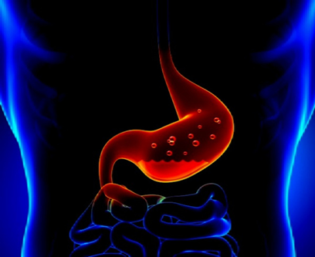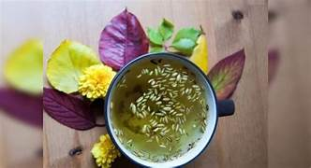

Acidity is a term used for a set of symptoms caused by excess production of acid by the gastric glands of the stomach. The stomach normally secretes hydrochloric acid which is required for the breakdown and digestion of food we eat. Acidity causes symptoms like dyspepsia, heartburn, gastric inflammation and ulcers in the stomach etc;

HOW TO REDUCE ACIDITY IN HOME REMIDIES:

1. Fruits-Sapota, banana, papaya, watermelon, apple
2. Daily drink warm water at least (3-4)liters intake.
3. Basil or tulasi leaves: Gives instant relief from acidity – Eat a few Tulasi leaves or boil 3-4 leaves in a cup of water & drink (early morning).
4. Jaggery or Gur: Gur with its high magnesium content helps boost intestinal strength.
5. Buttermilk or cheese : cheese contain lactic acid which normalize your acidity in the stomach.
6. 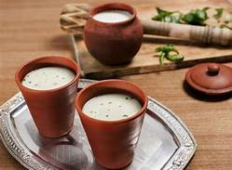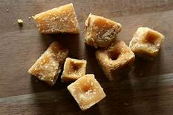Have a glass of buttermilk after eating a heavy or spicy meal.
7. Cold creams or ice creams: cold milk can neutralize acids in your stomach and can give you relief from acidity.
8. Fennel seeds or : you can chew after meals, to prevent acidity.
9. You can have fennel tea to keep the digestive track healthy & reduce the feeling of digestion &bloating.
10. Banana& apple : banana contain natural antacids that act as a factor to fight acidity.
11. Apple can relief heartburn or reflux.
12. Coconut water helps turn your body PH level from acidic to alkaline.
13. Cardamom or eliche : boil them in water, cool &drink to get instant relief;

AVOIDED FOOD FOR ACIDITY:

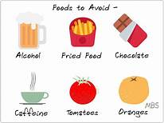

* Acidic (citrus fruits: orange, limes, lemons.
* Caffeine: like-coffee ,tea, soft drinks, energy drinks, chocolates
* Spicy foods: red chilies, peppers, hot sauces, fries foods.
* High -fat foods: fast food , cheeses
* Processed snacks/food like: potato chips, bacon, ham
* Tomatoes are very acidic/onions like : raw onions can induce heartburn
* Beverages : alcohol, beer, wine, cocktail, tamarind, fermented baters.